Q1. Gamified Learning Platforms Research
A. Research Problem & Objectives (5 Marks)
- Problem: Limited evidence exists on whether gamified learning platforms enhance collaborative skills among undergraduates.
- Objectives:
  - To measure the impact of gamification on teamwork and communication skills.
  - To compare collaborative skills between students using gamified vs. traditional platforms.
  - To identify design features of gamified platforms that influence collaboration.
B. Hypotheses (5 Marks)
- Null (H₀): Gamified learning platforms have no significant effect on collaborative skills.
- Alternative (H₁): Gamified learning platforms significantly enhance collaborative skills.
C. Sampling Method (5 Marks)
- Stratified random sampling ensures fair representation across departments and years. Justified because collaboration varies across disciplines.
D. Workflow (5 Marks)
Problem → Literature Review → Hypotheses → Sampling → Data Collection (LMS logs, surveys) → Analysis (ANOVA, regression) → Findings → Report.
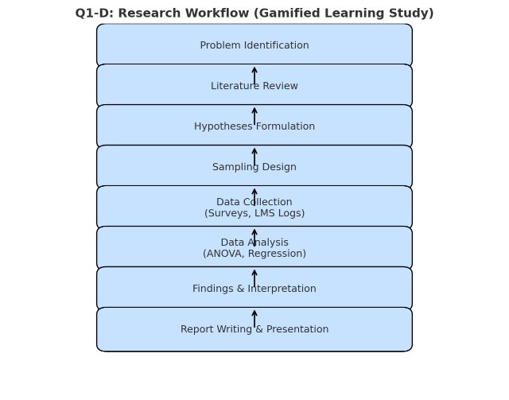
E. Digital Tools (5 Marks)
- Surveys: Google Forms for large-scale data.
- LMS: Track teamwork metrics.
- Databases (IEEE, Scopus): Access prior studies.

Q2. Systematic Review – Smart Healthcare IoT
A. Search Refinement (5 Marks)
- Keywords: “IoT healthcare,” “remote monitoring.”
- Boolean: AND, OR, NOT for precision.
- Citation chaining: Using references & citations of core papers.
B. Synthesis (5 Marks)
- Thematic coding: Groups findings into themes (e.g., privacy, efficiency).
- Concept mapping: Visualizes interconnections between concepts.
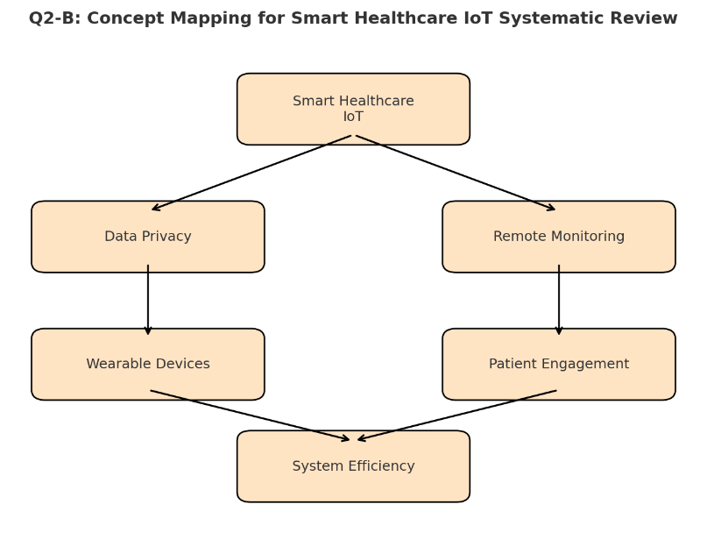
C. Credibility Framework (10 Marks)
- Impact factor (>2 strong journals).
- Author’s h-index (>20 shows influence).
- SJR values (Q1/Q2 journals more credible).
D. Systematic Review + Meta-synthesis (5 Marks)
- Combines quantitative evidence with qualitative insights → balanced, actionable conclusions for policy/industry.

Q3. Bibliometrics & Survey
A. h-index, i10, g-index (5 Marks)
- h-index: 30 papers → h = 23 (23 papers ≥ 23 citations).
- i10-index: 25 papers with ≥10 citations.
- g-index: Largest g where top g papers ≥ g² citations → g = 30 (since top 30 = 2073 ≥ 900).
- Visualization: Citations vs. Paper Rank (curve showing citation drop).
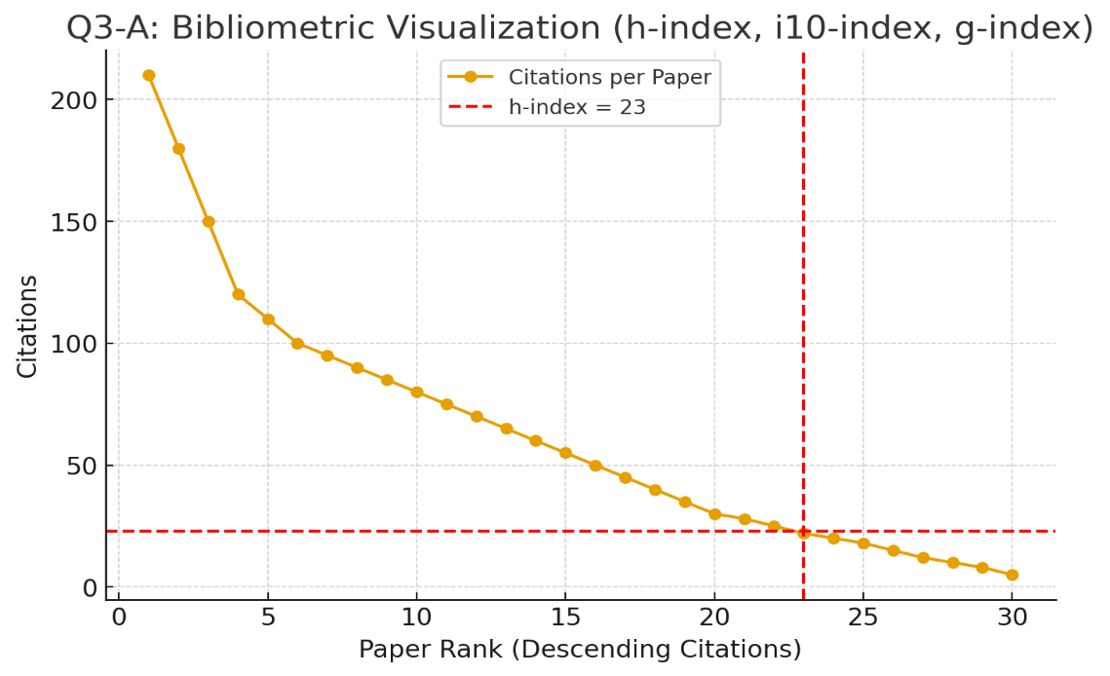
B. Impact Factor & CiteScore (5 Marks)
- Impact Factor 2023: (Citations in 2022+2021)/(Pubs 2022+2021) = (720+600)/(200+190) = 1320/390 = 3.38.
- CiteScore 2023: (Citations 2020–2023)/(Pubs 2020–2023) = (650+720+600+550)/(180+200+190+170) = 2520/740 = 3.41.
C. Questionnaire (5 Marks)
- Likert: (1) “Gamification improves my motivation.” (2) “I feel confident using e-learning platforms.”
- MCQs: (1) Device used (Laptop/Mobile/Tablet). (2) Frequency of usage.
- Ranking: (1) Rank features: cost, ease, interactivity. (2) Rank barriers: internet, content, training.
D. Research Types (5 Marks)
- Mindfulness–stress → Experimental.
- Historical temperature analysis → Historical.
- Public perception survey → Descriptive.
- Organic food demand → Exploratory.
- Hybrid vs. EV preference → Comparative/Descriptive.
E. AI Dropout Research (5 Marks)
- Problem: High dropout rates with limited prediction models.
- Objectives: (1) Develop AI model for dropout prediction, (2) Identify key risk factors.
- Design: Quantitative predictive research using student records and ML models.

Q4. Biodegradable Packaging Innovation
A. IPR Forms (5 Marks)
- Patent (novel material), Industrial design (appearance), Trade secret (manufacturing process).
B. Patent Filing Steps (5 Marks)
- Patent search.
- Draft specification.
- File at Indian Patent Office.
- Examination & response.
- Grant & publication.
C. Technology Transfer (5 Marks)
- Licensing agreements, industry partnerships, spin-off/startup creation.
D. Implications (5 Marks)
- Social: Health-friendly packaging.
- Environmental: Reduces plastic waste.
- Ethical: Accessibility vs. profit concerns.
E. Balancing Publishing vs. Protection (5 Marks)
- Delay publication until provisional patent filed.
- Publish non-sensitive aspects openly.
- Use dual strategy: academic openness + proprietary protection.

Q3. C.

Structured Questionnaire – Student Adoption of E-learning Platforms (5 Marks)
A. Likert Scale Questions (1–5: Strongly Disagree → Strongly Agree)
- E-learning platforms improve my overall learning effectiveness.
- I find e-learning platforms easy to use and navigate.
B. Multiple-Choice Questions
- What is your primary reason for using e-learning platforms?
  - a) Flexibility in learning time
  - b) Access to diverse resources
  - c) Cost-effectiveness
  - d) Peer/teacher recommendations
- Which device do you mostly use for accessing e-learning platforms?
  - a) Laptop/PC
  - b) Smartphone
  - c) Tablet/iPad
  - d) Others
C. Ranking/Preference-based Questions
- Rank the following factors influencing your choice of e-learning platform:
  - Content quality, User-friendliness, Cost, Peer interaction
- Rank preferred features in an e-learning platform:
  - Live lectures, Recorded videos, Quizzes/Assessments, Discussion forums

Structured Questionnaire – Student Adoption of E-learning Platforms (5 Marks)
Type | Question | Options/Scale
Likert Scale | 1. E-learning platforms improve my overall learning effectiveness. | 1 = Strongly Disagree → 5 = Strongly Agree
 | 2. I find e-learning platforms easy to use and navigate. | 1 = Strongly Disagree → 5 = Strongly Agree
Multiple Choice | 1. What is your primary reason for using e-learning platforms? | a) Flexibility b) Resources c) Cost-effectiveness d) Recommendation
 | 2. Which device do you mostly use for accessing e-learning platforms? | a) Laptop/PC b) Smartphone c) Tablet/iPad d) Others
Ranking / Preference | 1. Rank the factors influencing your choice of e-learning platform. | Content quality, User-friendliness, Cost, Peer interaction
 | 2. Rank the features you prefer in an e-learning platform. | Live lectures, Recorded videos, Quizzes, Discussion forums

